“To Gather Together With Friends”
Puckihuddle Preschool

Puckihuddle Programs 2016 - 2017
Program (Days) | Ages | Times | Rate
Tuesday / Thursday | 2.9 – 4 year olds | 9:00 a.m. – 12:00 p.m. | $1950/year
Tuesday / Thursday | 2.9 – 4 year olds | 9:00 a.m. – 2:30 p.m. | $3240/year
Monday / Wednesday / Friday | 3.8 – 5 year olds | 9:00 a.m. – 12:00 p.m. | $2370/year
Monday / Wednesday / Friday | 3.8 – 5 year olds | 9:00 a.m. – 2:30 p.m. | $4470/year
Lunch Bunch for MWF half-day students | Every Wednesday | 12:00 p.m. – 1:00 p.m. | $10 /day
Lunch Bunch for TUTH half-day students | One Thursday  per month (TBD) | 12:00 p.m. – 1:00 p.m. | $10 /day
Early Drop-Off | All registered students | 8:30 a.m. – 9:00 a.m. | $5 /day
Lunch Bunch
Lunch Bunch Wednesdays include 60-minutes of supervised lunch (parent-provided) and play. Lunch Bunch will be held every Wednesday starting the second week of school for the MWF half-day program. We will also offer Lunch Bunch once per month for the half-day TUTH program (specific dates TBD).

The cost for Lunch Bunch will be $10 per day. Parents will have the flexibility to sign up for one day at a time or the whole year. Advanced registration will be required so staffing and activities can be planned accordingly.

The Enrollment Process
If you would like to visit our school, request additional information or speak to a director, please call us at (508) 476-2939. We are always happy to meet and speak with parents and their children. We offer tours every Thursday at 10:00 a.m. or by appointment. Please call to sign up for a tour. Applications for admission are accepted on an on-going basis. If you are interested in enrolling your child, a $60 non-refundable registration fee is due when you enroll to secure your child’s spot.

6 Main Street
P.O. Box 432
Manchaug, MA 01526
(508) 476-2939
www.puckihuddlepreschool.com
A Little Bit About Us
Puckihuddle Preschool was established in 1981. Our program provides children and their families a high quality early childhood experience. Our classes are led by dedicated professionals who, through guidance, patience and understanding, will motivate, encourage and inspire each child’s desire to learn.

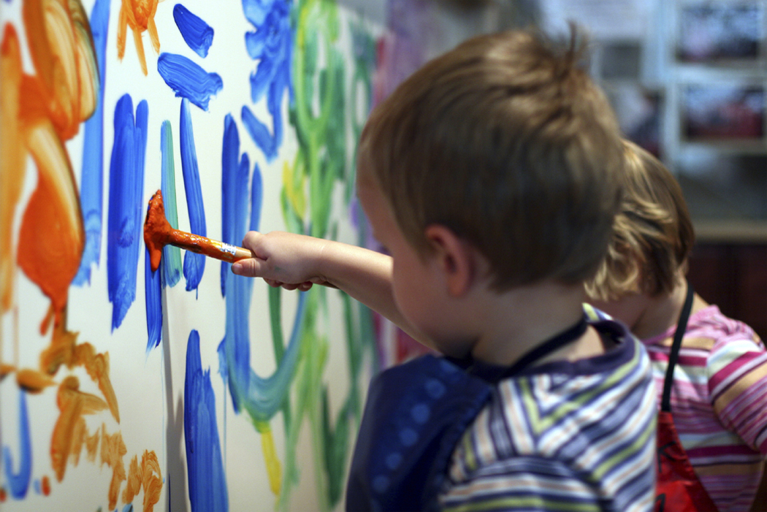
Our Philosophy
Puckihuddle Preschool is dedicated to providing your child with the best first experience at school. Our safe and nurturing atmosphere is filled with interesting and developmentally appropriate experiences which foster your child’s physical, social, emotional and intellectual development. Through a careful balance of teacher directed and child selected activities, your child will have the opportunity to play, explore, discover, inquire and learn. Our engaging, exciting child-centered curriculum encourages each child to grow and develop at his/her own pace. While in our care, we will offer your child consistency, security and safety in a warm, nurturing environment allowing them the opportunity to acquire a true love of learning.
6 Main Street
P.O. Box 432
Manchaug, MA 01526
(508) 476-2939
www.puckihuddlepreschool.com
Enrichment Programs
Puckihuddle Preschool is pleased to partner with Apple Tree Arts to provide quality music instruction to our students each month. In addition, we are fortunate to have a local, professional artist visit us to enrich our existing art program. We also appreciate the curiosity of young learners and foster this with a hands-on science program and occasionally welcome special guests for fun creative movement demonstrations.
Our Curriculum & Learning Activities
We believe children learn best through play. Our curriculum is child centered with developmentally appropriate materials which encourage creativity, problem solving skills, and a love of learning. The children learn teamwork and respect for the needs and feelings of others. Limits are set in ways that develop self-control and preserve self-esteem. Each session is carefully planned around a unit of study with the age and skills of the group in mind.

We believe children learn best by doing. Therefore, our structured, yet flexible daily schedule is filled with hands-on learning activities. There is a delicate balance between child-initiated and teacher guided activities as well as time for individual, small group and large group instruction. We incorporate art, blocks, books, cooking, dramatic play, small and large motor, games, language and literacy, math explorations, music & movement, nutrition, outdoor play, puppets, puzzles, science discoveries, and sensory play into our day. Each of these learning centers provides a place for children to explore, imagine and grow. Reading, writing, math, science, and social studies skills are a major focus of our program and are incorporated into our thematic curriculum during our meeting times, carefully planned lessons and learning activities.

We believe in each child’s individuality. Each child is unique and we want to nurture the individual spirit. We are prepared to meet the individual needs of your child and help achieve their highest potential by fostering curiosity, extending their thinking and making learning FUN!

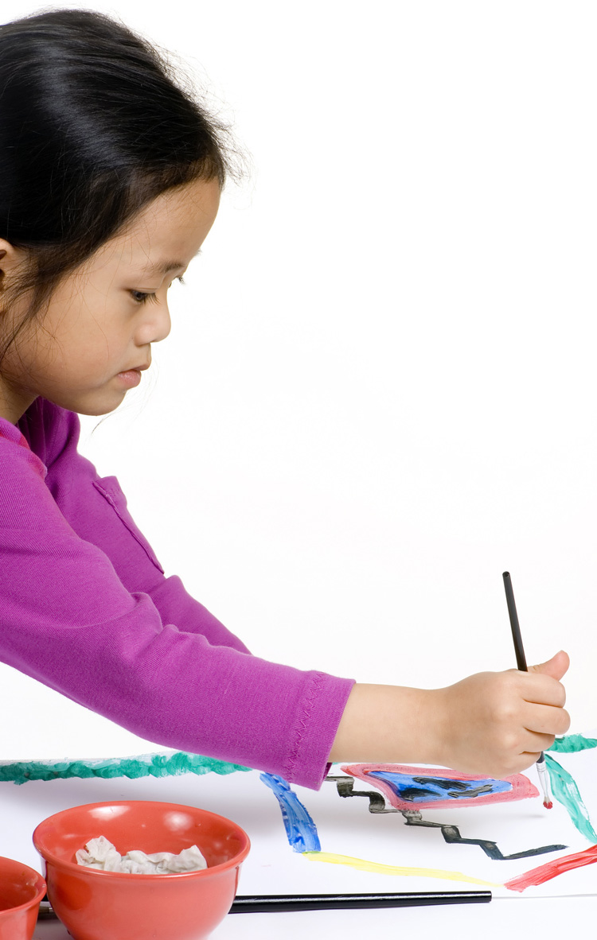

Communication
We highly value the relationship between home and school, and strive to provide relevant information in a variety of formats. In order to keep you informed about your child’s preschool experience, you will receive weekly classroom announcements, monthly newsletters and frequent email reminders. You will also participate in parent/teacher conferences where your child’s developmental progress will be discussed. At any time, you can communicate with your child’s teachers or directors via email, phone, note or meeting.

About Our Parents
As we work to establish a unique experience for your child, we strongly encourage your parental involvement. We consider parents our partners in education. Parents are invited to participate in the program through volunteering in the classroom, helping out with our Puckihuddle Parents Group and by attending fun family events. We also welcome parents or relatives to share their professions, hobbies, special interests, holidays or traditions with our students.

